Feasibilty Study

Ray’s Rentals

Table of Contents

1.0 Introduction 2

2.0 Problems 3

2.1 Lost or Missing Documents 3

2.2 Data Sharing 3

2.3 Retrieving Data 3

2.4 Security 3

2.5 Cost 3

3.0 System Requirements 4

3.1 Bike Record 4

3.2 Rental Record 4

3.3 Maintenance Record 4

3.4 Parts Record 4

3.5 Sold Bikes 4

3.6 Customer Record 4

4.0 Data Enquires and Management Reports 5

4.1 Data Enquires 5

4.2 Management Report 5

4.3 Types of Management Report 5

4.0 Date Enquires 6

4.1 Data Enquiries 6

4.2 Exception Reports 6

5.0 Management Reports 7

5.1 Analysis Reports 7

5.2 Key Target Reports 8

6.0 Conclusion 9

# 1.0 Executive Summary

This report will cover the advantages of using an electronic database in context of Ray’s Rentals, a large bike rental shop in a small town. The owner feels as if he is losing business and is looking for an alternative which can make his business easier. As the current database is paper based and there are specific requirements such as bike record and rental records which will be constantly being updated this report will aim to put forward a more efficient model.

# 2.0 Problems

Rey’s Rentals currently uses a paper based system for his bike shop. All data for the bikes such as type, unique number and maintenance history is all noted down on paper, any reservations for a bike are also noted down on paper including customer’s details such as name and number. This paper based system has already caused problems for Rey’s Rentals bike shop.

## 2.1 Lost or Missing Documents

* The first problem with the current paper based system is lost and missing documents according to Cooper and Lybrand “7.5% of all documents gets lost and 3% of the remainder is misfiled”. Ray has already stated that due to reservations being weeks in advance “that reservations can get lost among other reservations. Being a paper based system there are no backups if a reservation gets lost leading to reserved bikes being rented out to another customer.

## 2.2 Data Sharing

* A second problem is data sharing. Paper based systems are located in one place, meaning that is Ray needed to access any records from home or share data with other employees this would be impossible. This lack of data sharing means a decrease in efficiency for Ray’s Rentals as data is only stored in one place.

## 2.3 Retrieving Data

* Slow access is another problem of a paper based system. Finding and retrieving data in paper based system is very slow and inefficient, it would be very difficult for Rey to retrieve any data about a certain customer or bike if required.

## 2.4 Security

* A fourth problem with a paper based system is security. With a data base the data can be encrypted, but with a paper based system all data

## 2.5 Cost

* One of the biggest problems with a paper based system is the high cost. All the problems stated above lead to a high cost system. Firstly, the cost of materials for Rey will be extremely high, noting down every detail about each bike and customer takes a huge amount of paper and storage. Furthermore, the cost of organizing documents to ensure document control and the labour cost is huge.

# 

# 3.0 System Requirements

Below is a list of requirements that have been drawn up for the proposed new computerised database system for Ray’s Rentals.

To fully serve its purpose the new system should have 6 tables, the requirements for each table for the proposed new system are outlined below.

## 3.1 Bike Record

* This record should be used to keep track of all bikes that Ray’s Rentals have in stock. Each bike should have its own unique ID as per the current process.
* To improve usability, the record should include the option to filter by classification of size, model, manufacturer and date of purchase of bikes that Ray’s Rentals have in stock.

## 3.2 Rental Record

* This record should be used to check for the availability of bikes for hire on any particular day and time.
* This record should also enable staff to enter customer details in order to reserve bikes and enter payment details.

## 3.3 Maintenance Record

* This record should be able to flag up bikes that have not been serviced for a month.
* Staff should also be able to update the record when bikes have been serviced.
* There should also be a facility to record faults that have been reported by customers.

## 3.4 Parts Record

* Staff should be able to use this record to check for stock levels of bike parts and be able to order parts that are low in stock. It could also flag up parts which are low in stock to reduce risk of missing parts that are low in stock.
* This record should also allow staff to record deliveries of bike parts.

## 3.5 Sold Bikes

* This record should allow the viewing of bikes that have been sold by Ray’s Rentals. Bikes that have been sold for two years should be deleted automatically from this record.

## 3.6 Customer Record

* This record should be used to bring up details of customers’ who have reserved bike(s), such as name, address, bike they have reserved and whether they have paid.

# 

# 4.0 Data Enquires and Management Reports

## 4.1 Data Enquires

According to David Whitely a data enquiry is “The final type of report... All systems need to give the facility to look up each element of standing data and any transaction.” In a database system, enquiries can be made about any details such as customer name, date or invoice. Usually data enquires are searched using a primary key, but can also be enquired by other details if the primary key is unknown. This is an operational level report; the output of the enquirer is usually displayed simply on the users’ screen. Data enquires are a simple but efficient way of retrieving data.

## 4.2 Management Report

Management reports are used in organisations to outline how much the money have made or lost. These reports are utilised usually by high management or CEO/CFO’s so that they know how well the business is doing. These reports can be annually or quarterly depending on the size of the business and required purpose. The report can be used to strategies or see how well a new strategy is working.    

## 4.3 Types of Management Report

# 4.0 Data Enquires

## 4.1 Data Enquiries

Ray and his staff members will be making many data enquiries during the business’ operational hours. The enquiries made are usually relevant to the tasks required of the staff members. One scenario is when a customer requests to hire a specific bike. A data enquiry will need to be made by one of Ray’s staff to check if that particular bike is available to rent. A search/query could be made by searching the database using the model of the bike or the bike ID. Figure 1 illustrates this below.

Another example of a data enquiry at Ray’s Rentals is if a member of staff needs to know when a customer will be returning a bike. This could be because another customer is waiting for the same bike or the bike is due some maintenance for example. An enquiry can be made using the booking reference and then checking the return date for that particular booking.

A third example is when Ray’s maintenance staff need to repair a bike. If they need to check if a part is available in the shop, they can simply do a search for the part using the part ID. If the part is available, the repairs can be done there and then. If not, the part can simply be ordered and the repairs can be scheduled.

Bike ID

Bike ID

*Figure 1*

## 4.2 Exception Reports

Exception reports, unlike analysis reports, will show Ray things that need ‘sorting out’ in the business. However, the chances are that Ray will need more information known as diagnosis information before he can understand or attempt to rectify the problem(s). If this does happen to be the case, an interactive report is produced. Generally, diagnosis information is accessed via the click of a button to avoid clutter on the page. An example of an exception report at Ray’s Rentals could be a list of all the customers that haven’t paid for the rental of a bike yet with the diagnosis information being the customer’s contact details such as phone number, address, e-mail etc. which will enable Ray or his management to deal with the problem directly. An example of this is below.

|  |  |  |  |  |  |
| --- | --- | --- | --- | --- | --- |
| Customer ID | Name | E-mail | Address | Total Owed | Paid |
| 1234 | Joe Bloggs | [j.bloggs@mmu.ac.uk](mailto:j.bloggs@mmu.ac.uk) | 123 Oxford St, Manchester | £100 | Yes |
| 12345 | Tom Smith | [t.smith@mmu.ac.uk](mailto:t.smith@mmu.ac.uk) | 124 Oxford St, Manchester | £200 | No |

# 5.0 Management Reports

## 5.1 Analysis Reports

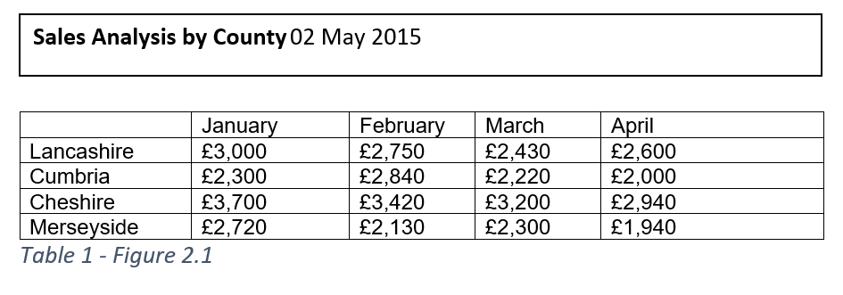

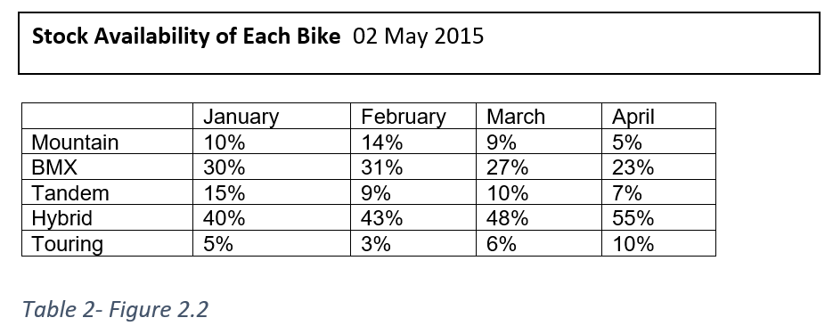

Tables figure 2.1 and figure 2.2 show data enquires about Rays bike shops. Figure 2.1 is a data enquiry about the sale figures for the first quarter for 2015 of 4 counties in the North West. Figure 2.2 is data enquiry about the stock availability of 5 different bikes which Ray’s Bike shop offers of the first 4 months of 2015. Ray will be able to make data enquiries for future months and years.

Another example of a data enquiry Ray could make is to check which of the bikes Ray has the highest demand so for example Ray may want to buy more Mountain bikes rather than buying BMXs as they are not really sought after in each of the counties.

## 

## 5.2 Key Target Reports

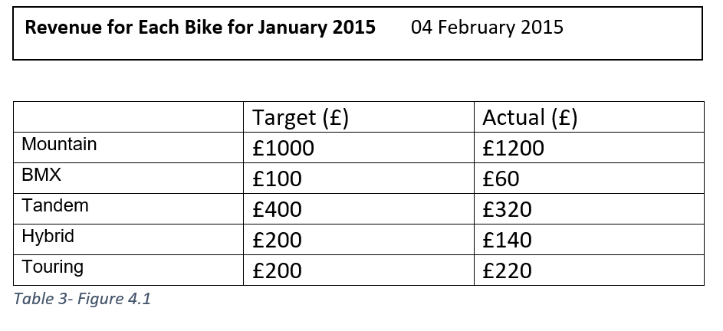

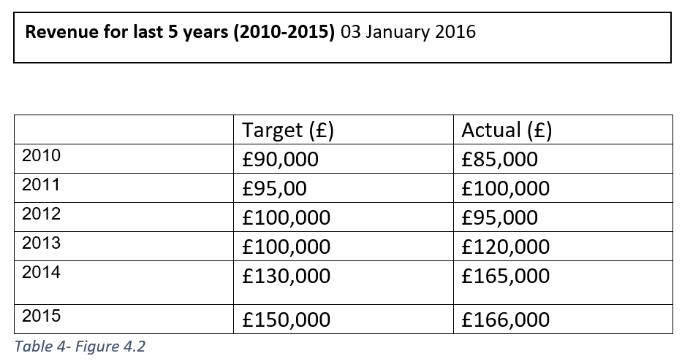

Tables figures 4.1 and 4.2 shows data enquires about Rays bike shops about the revenue for the shop. Figure 4.1 is a data enquiry about the revenue for the month of January 2015. The figures show the targeted revenue for each bike and the actual sale figures for each of the bikes. Figure 4.2 shows the data enquiries shows the revenue made from the past 5 years (2010-2015), the target revenue with the actual revenue.

Another example of a data enquiry Ray could make is to determine whether the business is viable and that it is making him money than losing him money each year. This could be used to check whether people are interested in renting out bikes.

# 

# 6.0 Conclusion

In conclusion this report outlines the benefits and increased flexibility a paperless system could offer Ray’s Rentals. It also highlights how important information can be represented in a variety of reports, which will assist Ray in minimizing losses and increasing efficiency within the business.